世界地质公园网络——2018年地质公园年度报告
Global Geoparks Network - Geopark Annual Report 2018

1.公园身份
1. Geopark Information
地质公园名称、国家、区域网络：昆仑山联合国教科文组织世界地质公园（中国、亚太地质公园网络）
Geopark name, country, regional network: Mount Kunlun UNESCO Global Geopark (China, Asia-Pacific Geoparks Network)
加入年份/上次再评估年份：2014年9月成为我国第 30 个世界地质公园，2018年7月第一次中期评估。
Year of accession/Year of latest reassessment: accession in September 2014 as the 30th global geopark of China; first mid-stage assessment in July 2018.
代表性照片：（本年度最重要活动）
Representative photos: (the most important events in 2018)
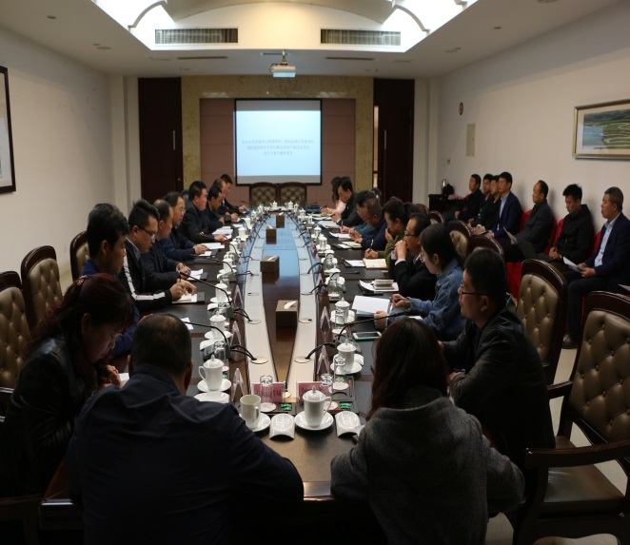  昆仑山世界地质公园地质遗迹保护及景区解说系统升级改造项目评审会  Review Meeting for the Project of Protection of Geological Relics and Upgrading and Reconstruction of Scenic Spot Interpretation System for Mount Kunlun Global Geopark | 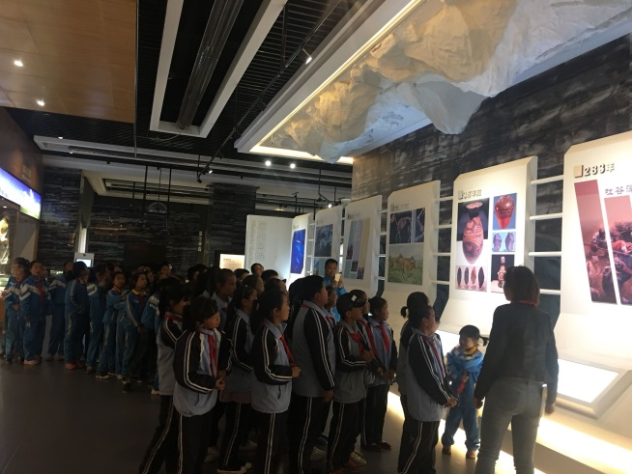  4月22日“世界地球日”组织学生参观昆仑山世界地质公园博物馆  Organizing Students to Visit the Museum of Mount Kunlun Global Geopark on April 22, the Earth Day
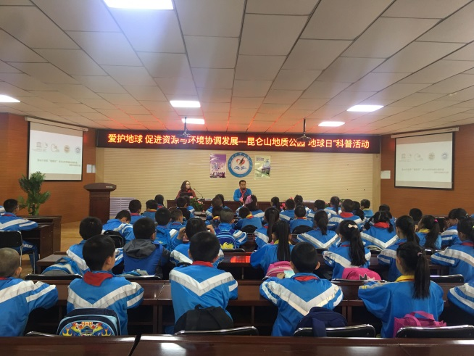  昆仑山世界地质公园开展“世界地球日”科普教育活动  “Earth Day” Science Popularization Education Activity Conducted by Mount Kunlun Global Geopark | 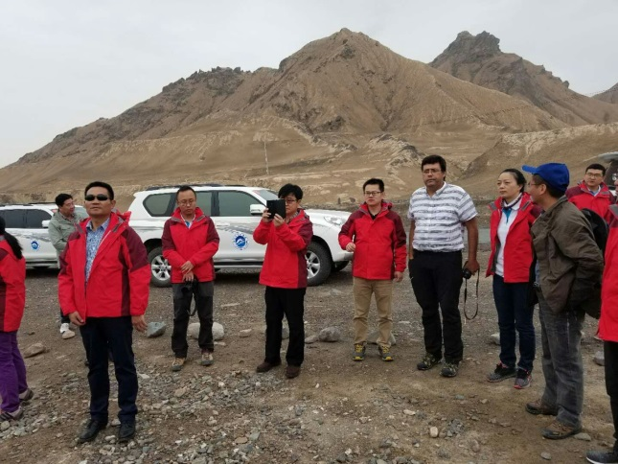  2018年中期评估现场考察  Site Visit for Mid-stage Assessment in 2018
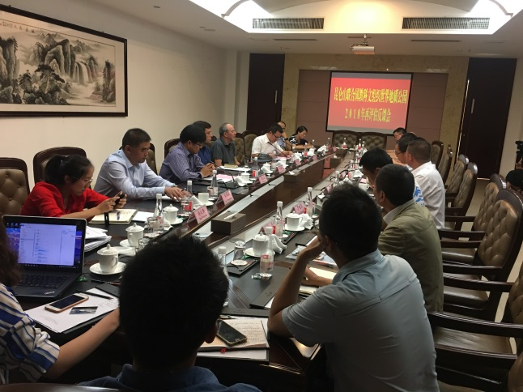  2018年中期评估反馈会  Feedback Meeting for Mid-stage Assessment in 2018 | 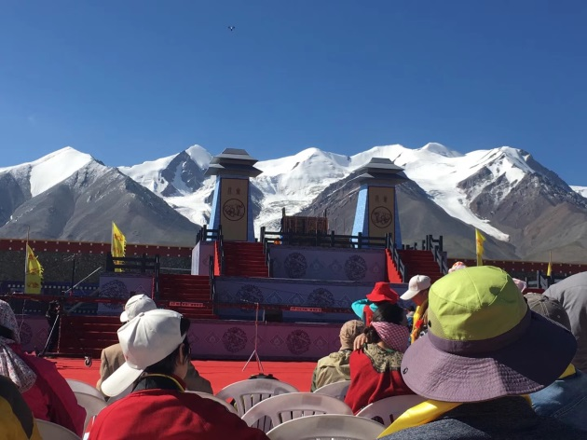  2018年拜山大典  Mountain-worshiping Ceremony in 2018

2.地质公园数据
2. Data of the Geopark
员工人数：公园目前有员工9人，技术支撑单位员工6人，另外公园专家委员会共有3名专家。
Number of employees: There are currently nine (9) employees in the park, including (6) technical support employees and three (3) experts from the Geopark Expert Committee.
游客人数：2018年公园接待游客83.45万人次，博物馆接待游客旅游6000人次。
Number of tourists: In 2018, the Geopark received 834,500 person-times of tourists and the Museum received 6,000 person-times of tourists.
活动次数：（阐明由管理机构和合作单位组织的活动）
Number of activities: (Clarify the activities organized by the management organization and the partner organizations)
2018年共开展各项活动10余次。
More than 10 activities were carried out in 2018.
2018年4月，公园携手中山路小学，郭勒木德镇中心学校一起在世界地质公园博物馆开展了地质科普活动；
In April 2018, the Geopark, together with Zhongshan Road Primary School and Guolemude Town Central School, carried out the geological science popularization activity at the Museum of Mount Kunlun Global Geopark;
2018年4月，公园在“世界地球日”到中山路小学进行了“爱护地球 促进资源与环境协调发展”主题科普教育活动；
On the Earth Day in April 2018, the Geopark carried out the science popularization education activity on the theme of “Caring for Our Earth - Promoting the Harmonious Development of Resources and Environment” in Zhongshan Road Primary School;
2018年4月，在昆仑山世界地质公园博物馆对来自台湾的游客开展了“昆仑文化”主题科普教育活动；
In April 2018, the Geopark carried out the science popularization education activity on the theme of “Kunlun Culture” at the Museum of Mount Kunlun Global Geopark for the visitors from Taiwan;
2018年5月，公园面向全国青少年开展“2018年青藏高原避暑研学游夏令营”活动；
In May 2018, the Geopark carried out the activity of “Study-themed Summer Camp in Qinghai-Tibet Plateau 2018” for the juveniles across China;
2018年7月，在昆仑山世界地质公园博物馆对十一世班禅额尔德尼一行人开展了“走进昆仑山世界地质公园”主题科普教育活动；
In July 2018, the Geopark carried out the science popularization education activity on the theme of “Understanding the Mount Kunlun Global Geopark” at the Museum of Mount Kunlun Global Geopark for the 11th Panchen Erdeni and his followers;
2018年9月，公园对盐湖股份有限公司的60余名退休职工开展了科普教育活动；
In September 2018, the Geopark carried out the science popularization education activity for over 60 retired workers of Qinghai Salt Lake Industry Group Co., Ltd.;
2018年10月，公园对路东社区进行了“环境保护”主题科普教育活动；
In October 2018, the Geopark carried out the science popularization education activity on the theme of “Environmental Protection” for the Ludong Community;
2018年10月，公园到格尔木市消防队进行“走进昆仑山世界地质公园”主题科普教育活动。
In October 2018, the Geopark carried out the science popularization education activity on the theme of “Understanding the Mount Kunlun Global Geopark” at the Golmud Municipal Fire Brigade;
2018年11月，公园对玲珑湾小区社区居民开展了“走进地质公园”主题科普教育活动；
In November 2018, the Geopark carried out the science popularization education activity on the theme of “Understanding the Geoparks” for the residents of Linglongwan Community.
开展地质公园教育计划的学校班级数：青海省格尔木市第二中学、青海省格尔木市江源路小学。
Number of schools carrying out the geopark education program: Qinghai Golmud No. 2 School and Qinghai Golmud Jiangyuan Road Primary School.
地质公园发表新闻稿数量：2018年发表20余篇
Number of press releases issued by the Geopark: more than 20 in 2018
3.地质公园活动（分项列出）：2018年中国青海格尔木市昆仑文化旅游节活动7月在昆仑山西大滩举行了拜山大典，有世界各地国外友人、国内相关媒体及游客参加；
3. Geopark activities (listed separately): Kunlun Cultural Tourism Festival in Golmud City, Qinghai Province, China in 2018; Mountain-worshiping Ceremony in Xidatan of Mount Kunlun in July, attended by foreign friends from all over the world and the relevant media and tourists in China;
2018年主要成就：中期评估工作顺利通过
Major achievements in 2018: successfully passing the mid-stage assessment
对GGN的贡献——网络活动和参与：2018年第九届中国世界地质公园年会（中国 雁荡山）；
Contribution to GGN - network activities and participation: Participated in the 9th Annual Meeting on China’s UNESCO Global Geoparks in 2018 (Yandangshan, China);
2018年12月参加第四届联合国教科文组织世界地质公园国际培训班（中国 北京）。
Participated in the 4th International Training Course on UNESCO Global Geoparks in December 2018 (Beijing, China).
管理和财务状况：公园管理机构为青海格尔木昆仑山国家地质公园管理局。2018年公园收入1000万元，经费主要来源于格尔木市政府和上级政府的专项经费，用于博物馆消防改造、取暖改造、中期评估、以及公园管理运营、员工工资等。
Management and financial situation: The management organization of the Geopark is the Administration of Mount Kunlun National Geopark in Golmud, Qinghai. In 2018, the income of the Geopark was RMB 10 million. The funds were mainly the special funds from the Golmud Municipal Government and the superior governments and used for improvement of fire fighting for the Museum, heating renovation, mid-stage assessment, management and operation of the Geopark and salaries of the employees.
地质遗迹保护：2018年，新建了公园管理数据库，是一套集地质公园有关空间数据与属性管理数据为一体的综合性数据库。
Protection of geological relics: In 2018, the geopark management database was created. It is a comprehensive database integrating spatial data and attribute management data of the Geopark.
2018年7-8月，青海格尔木昆仑山国家地质公园管理局修复了惊仙谷冻胀丘（泥火山型冰丘）的保护围栏。
In July to August 2018, the Administration of Mount Kunlun National Geopark in Golmud, Qinghai repaired the protection fences for the frost heaving mound (mud volcano type drumlin) at Jingxian Valley.
2018年6-8月，青海格尔木昆仑山国家地质公园管理局为Ms8.1级地震地表破裂带修建了保护顶棚。
In June to August 2018, the Administration of Mount Kunlun National Geopark in Golmud, Qinghai built a protection canopy for the surface rupture zone generated by an Ms8.1 earthquake.
公园每年在地球日、科普日等节日，开展公众地质遗迹保护工作的宣传，使之成为广大群众的自觉行动。
On every Earth Day, Science Popularization Day and other festivals in each year, the Geopark carried out publicity of protection of geological relics to the public, making the protection of geological relics become a conscious action of the masses.
可持续旅游（地学旅游）：
Sustainable tourism (Geo-tourism):
公园2018年共组织地学旅游10余次，主要是本地中小学生、外地中小学生、大学生的研学旅游。
The Geopark organized the geo-tourism for more than 10 times in 2018, mainly including educational tourism for local primary and secondary students, foreign primary and secondary students and college students.
有关地质遗迹保护、可持续发展和减少灾害风险的新教育计划：
New educational programs on protection of geological relics, sustainable development and disaster risk reduction:
2018年10月，公园与格尔木市地震局合作在中山路小学组织开展了一次学生地震灾害演习活动，增强了中学生的防震意识。
In October 2018, the Geopark, in cooperation with the Golmud Earthquake Administration, organized and carried out a student earthquake disaster drill in Zhongshan Road Primary School, raising the awareness of middle school students on earthquake prevention.
战略合作伙伴：公园为合作伙伴——昆仑山雪山矿泉水公司编制了《昆仑山世界地质公园合作伙伴——昆仑山雪山矿泉水有限公司宣传页》
Strategic partners: The Geopark prepared Brochure for Kunlun Mountains Snow Mountain Mineral Water Co., Ltd., a Cooperative Partner of Mount Kunlun Global Geopark for its partner Kunlun Mountains Snow Mountain Mineral Water Co., Ltd.
公园与黄河国际大酒店、玲珑湾酒店、兴龙大厦酒店、青港宾馆、四季春天酒店等有合作关系；
The Geopark established the cooperation relationship with Huanghe International Hotel, Linglongwan Hotel, Xinglong Tower Hotel, Qinggang Hotel and Siji Chuntian Hotel;
公园与云舟旅行社、先大旅游汽车公司有合作关系；
The Geopark established the cooperation relationship with Yunzhou Travel Agency and Xianda Tourist Automobile Company;
公园与晟圆春生态园、天天农家乐等当地农家乐有合作关系。
The Geopark established the cooperation relationship with local agritainments including Shengyuanchun Ecological Park and Tiantian Agritainment.
宣传推广活动：2018年5月公园到全国各大城市开展“大美青海，美在海西”旅游资源宣传推介会；
Publicity and promotion activities: In May 2018, the Geopark carried out the tourism resource publicity and promotion on the theme of “Haixi, the Land of Beauty in Beautiful Qinghai” in various big cities across China;
2018年6月公园参加第十九届中国 青海绿色发展投资贸易洽谈会。
In June 2018, the Geopark participated in the 19th Qinghai China Investment & Trade Fair for Green Development.
4. 联系人：冯自光
4. Contact: Feng Ziguang
管理者：冯自光，klsdzgy@163.com
Manager: Feng Ziguang, klsdzgy@163.com
科学负责人（地质学家）：赵志中 第四纪冰川研究
Scientific leader (Geologist): Zhao Zhizhong engaged in quaternary glacier research

